

Swyddfa’r Cyngor ● Canolfan Gymdeithasol Bro Ffestiniog ●Heol Wynne
● Blaenau Ffestiniog ● Gwynedd ● LL41 3UF
 01766 832 398  clerc @cyngortrefffestiniog.cymru

MINUTES

ORDINARY MEETING

10th June 2021

MINUTES OF THE FFESTINIOG TOWN COUNCIL ORDINARY MEETING
HELD ON THURSDAY 10th JUNE 2021
ONLINE AT 7.00 PM.

CHAIR: Councillor: Erwyn Jones

PRESENT: Councillors: Rory Francis, Ronwen Roberts, Mark Thomas,
Glyn Daniels, Annwen Daniels, Bedwyr Gwilym,
Gwenlli Evans, Alun Jones, Nathan Jarvis.

11037/06/21 1. APOLOGIES
Councillor Dafydd Dafis.

11038/06/21 2. DECLARATION OF INTEREST
None.

11039/06/21 3. URGENT MATTERS
Matters which, in the opinion of the Chairman, should be considered at the meeting as a matter of urgency, pursuant to Section 100B (4) of the Local Government Act 1972.
Note for discussion only, no decision on an issue raised here is allowed but scheduled for the next meeting.

An email was received from Kiki Rees-Stavros that she intends to end the lease agreement at the Park Pavilion. Official confirmation is expected where one month's notice is given before finishing.

The Chair welcomed the two new Town Councillors, wishing them well for the work ahead.

11040/06/21 4. PRESENTATION BY CERI CUNNINGTON, CWMNI BRO: “PROJECTS OVERVIEW 2021-22”.

Councillors received an update from Ceri Cunnington on various various schemes that are developing in the area, including:

• Fuel heating scheme at Tanygrisiau - Feasibility Study currently underway to look at possible solutions to tackling fuel poverty through Y Dref Werdd and Sustainable Energy
• Save for Ever Scheme - Assist housing that falls below the favorable threshold of being able to heat the house. 37 houses are part of the scheme and receive various assistance such as solar panels and insulation measures.
• Cwmni Bro are keen to work with Tanygrisiau to create a village plan rather than several separate schemes. A small group called 'Tanygrisiau Fire' is looking to get a grip on village issues, and Cwmni Bro are keen to support them.
• 'Footprint' Scheme - Cwmni Bro has partnered with Coleg Llandrillo Menai and Gwynedd Council to offer a scheme that can benefit small local businesses. Aim for local businesses to benefit, and also young people in the area in obtaining work placements. 53 young people aged 16-25 claiming qualifying credit benefit present, The scheme has already created 50 work placements.
• Meeting held with MP Liz Saville-Roberts and MP Mabon ap Gwynfor to discuss the railway line from Blaenau Ffestiniog to Trawsfynydd. Meeting with officers of the Heritage Railways Association shortly. Looking for more robust responses before holding a public meeting.
• Antur Stiniog owns 49 High Street, Gisda's office, working with Gwynedd Council, Gorwel and Gisda to develop the building to be more suitable for homeless young people.
• Cwmni Bro working with the Urdd to transfer the building over to Antur Stiniog. Early talks but a desire to hear from the wider community of needs. Working with Mudiad Meithrin at present to temporarily house Cylch Meithrin in the Urdd building, until the cylch's permanent home is ready on the Ysgol Maenofferen site.
• Café Antur Stiniog will be trialling late night opening one a week specifically for young people in the area. Times and dates to be confirmed.
• Electric community vehicle coming to the area (7 seats). Will be available to hire to local associations and groups at cheap price for community purpose.
• A climate change worker will be starting in the area shortly, who will try to tackle climate issues and start a climate change Assembly.
• Willing to share plans made for 5 High Street to see if a scheme is now more suitable for the Community Centre, especially in terms of funding the building infrastructure.
• 'Dolan' scheme - looking to communitalise holiday homes in the Nantlle, Ogwen and Ffestiniog area. Strive to tackle the challenge, not solve the whole problem but look at owning housing that is unsuitable for local families, that the income generated from these community owned holiday homes stays in the area.
• Want to work closely with the Town Council on this final scheme - a High Street employee. Cwmni Bro have been successful in applying to the Welsh Government for a worker 3 days a week to work with high street businesses, and look for that person to potentially be employed by the Town Council, so that they can also develop the community wi-fi scheme alongside the high street businesses.

DECISION: The chair thanked the speaker for the presentation. Ceri Cunnington left the meeting at 7.35pm.

11041/06/21 5. POLICE ISSUES

No police member present and no issues to discuss.

11042/06/21 6. TO RECEIVE AND CONFIRM THE MINUTES OF THE ANNUAL MEETING ON THE 13th MAY 2021.

DECISION: That the Minutes be received and confirmed, with Councillor Glyn Daniels proposing and Councillor Rory Francis seconded.

11043/06/21 7. TO RECEIVE AND CONFIRM THE MINUTES OF THE ORDINARY MEETING ON THE 13th MAY 2021.

DECISION: That the Minutes be received and confirmed, with Councillor Glyn Daniels proposing and Councillor Rory Francis seconded.

11044/06/21 8. TO RECEIVE AND CONFIRM THE MINUTES OF THE EXTRAORDINARY MEETING ON THE 20th MAY 2021.

DECISION: That the Minutes be received and confirmed, with Councillor Gwenlli Evans proposing and Councillor Ronwen Roberts seconded.

11045/06/21 9. PAYMENTS DUE

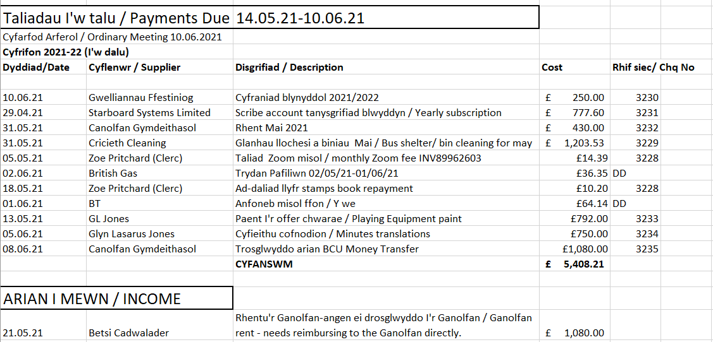

DECISION: The Clerk was authorized to pay the above.

11046/06/21 10. COUNCIL MONTHLY ACCOUNTS

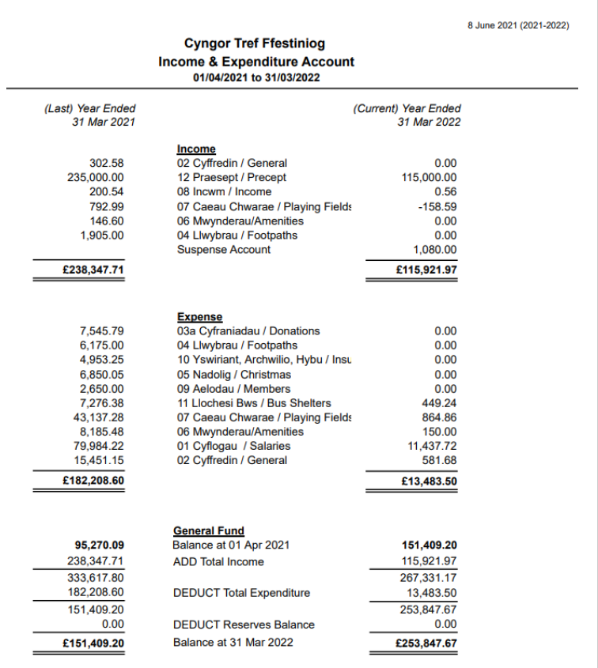

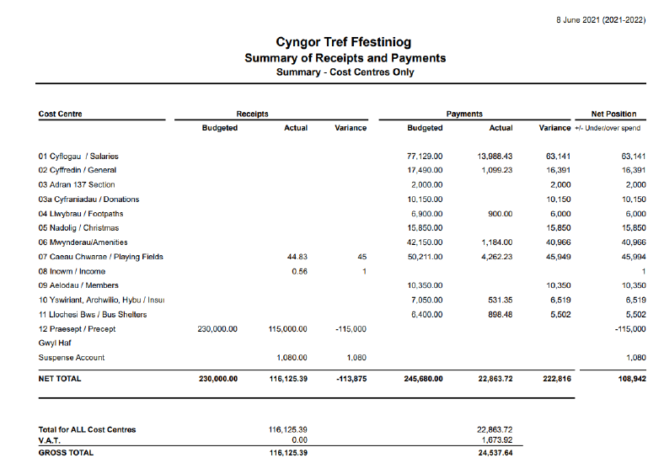
DECISION: To accept the accounts.

FINANCIAL APPLICATIONS
11047/06/21 11. Ysgol y Moelwyn – Rugby Officer - £2,000.00
11048/06/21 12. Gwallgofiaid – Clwb Clinc – Contribution of £8,850.00 on the condition that Gwallgofiaid secure the remaining match funding first. This contribution to be taken from the Town Council’s financial budget heading “Youth Club”.
11049/06/21 13. Paul Cameron Jones – Community Football - £400.00
11050/06/21 14. Tŷ Gobaith / Hope House - £150.00

11051/06/21 15. REGULATORY COMMITTEE
To accept the recommendations of the Regulatory Committee on Thursday 20th of May 2021

RECOMMENDATIONS OF THE REGULATORY COMMITTEE
THURSDAY 20th MAY 2021
ONLINE VIA ZOOM AT 7pm

Present: Apologies:
Councillors: Councillors:
Erwyn Jones Glyn Daniels
Gwenlli Evans Mark Thomas
Bedwyr Gwilym Annwen Daniels
Rory Francis Mel Goch ap Meirion.
Ronwen Roberts

1. To Receive Apologies
Apologies from Councilors Mark Thomas, Glyn Daniels, Mel Goch ap Meirion and Annwen Daniels.

Recommend: To accept the apologies.

2. Declaration of Personal Interest
NONE

3. Election of Chairman
The Committee elected the Chair as it was the first meeting following the AGM.
The Committee agreed to elect Councillor Erwyn Jones as Chair of the Regulatory Committee for 2021/22.

4. Discuss Planning Applications to hand

a) Planning Application No: C21 / 0409/03 / DT
Neuadd Ddu Farm, Manod, Blaenau Ffestiniog, LL41 4AL
Extension and alterations to dwelling house
DECISION: To support the application following a decent and stylish extension to the existing building.

b) Planning Application No: C21 / 0269/03 / LL
Glanypwll Workshops Glanypwll Road, Glan Y Pwll, LL41 3NW
Change of use and conversion of workshops into 4 self-contained holiday units, with spa and art gallery.
DECISION: To support the application as it made use of vacant units and offered a new service to the area.
Some features of the application form were disagreed, namely:
1. It is noted that there are no bats in the building, and Councillors report that bats have historically been on the site, and a bat survey should be undertaken to ensure this.
2. It is noted that no work was being done on the roof, but it is confirmed that work on the roof, and indeed parts of the roof completely removed, had taken place in recent weeks.

The meeting closed at 7.35pm.

DECISION: To accept the recommendations of the Amenities Committee with Councillor Rory Francis proposing and Councillor Glyn Daniels seconding the motion.

11052/06/21 16. AMENITIES COMMITTEE
To accept the recommendations of the Amenities Committee on Thursday
20th May 2021.

AMENITIES COMMITTEE RECOMMENDATIONS
Thursday evening 20th May 2021
Online via Zoom AT 7.00pm

Present: Apologies:
Councillors: Councillors:
Erwyn Jones Glyn Daniels
Gwenlli Evans Mark Thomas
Bedwyr Gwilym Annwen Daniels Rory Francis Mel Goch ap Meirion
Ronwen Roberts

1. Apologies
Apologies from Councillor Mark Thomas, Glyn Daniels, Mel Goch ap Meirion, Annwen Daniels.

Recommendation: To accept the apologies.

2. Declaration of Personal Interest
NONE

3. Elect Chair.
The Committee elected a Chair as it was the first meeting following the AGM.
The Committee agreed to elect Councillor Rory Francis as Chair of the Amenities Committee for 2021/22, proposed by Councillor Gwenlli Evans, seconded by Councillor Ronwen Roberts

4. Discuss the Town Council's grass cutting plans and identify areas of grass that can be left to grow longer.

Councillor Ronwen Roberts expanded on the idea of ​​not cutting some areas of playing fields to encourage wildflowers. The Committee agreed to pilot the idea in just one playing field for this year, Oakeley Square Field. And that's on the open area, but to keep cutting the playing field and football pitch and natural walk way 5 times a year as usual.

Councillor Bedwyr Gwilym noted that the grass cutting agreement needed to be considered in the discussion, and that the contractor would not lose out if the mowing works were reduced. He also mentioned that Councillor Mel Goch ap Meirion had already identified a risk of the possibility of glass and hazardous litter amongst long grass, and as a result the Town Council has a duty to take that risk seriously with its duty Health and safety.
Councillor Erwyn Jones mentioned that there is also a potential risk with snakes in long grass.
It was noted that it would be useful to check who owns Cae Tanygrisiau, in order to understand the responsibility.

Councillor Bedwyr Gwilym suggested to pilot the idea with just one field this year, so that an assessment could be carried out before spreading the plan to other fields.
Oakeley Square Field has been agreed for trial this year and not cut until July, but to continue to cut the park and football pitch area, and the natural walking trail.

It was suggested that a publicity campaign was needed on Facebook to spread the message that the Council was trialling to make the venues richer with flowers and wildlife. Councillor Gwenlli Evans suggested writing a small article for the press. Make small signs for the field explaining why a break has not happened.
It was agreed that the experiment needed evaluation in September 2021, and that the evaluation sought the input of local residents about the trial and the wildlife.

RECOMMENDATION:
• Piloting the scheme at Oakeley Square Field for this year, but to continue cutting the playing field, football pitch and natural walkway 5 times a year as usual.
• Promote the pilot through Facebook, press and create small field signs.
• Evaluate the pilot in September, and involve local residents.

5. To consider p.Helen Jones's invoice for Baltic Field work to be paid.
The fact that the invoice was higher than the original quote from the work was discussed much more than the original objective. Need to check the contractor's capacity with a waste carrier license for the future. Remind all contractors to contact the Clerk if price changes occur in the future.
Recommend: Agree to pay the invoice.

6. Organize 1st Park Partnership meeting
4 members of the public contacted following a campaign on Facebook to resurrect the Park Partnership. It was agreed to contact Councillor Mark Thomas to agree a meeting date and time.

7. Review the pavilion agreement and identify any necessary changes to it.
The Clerk noted that there was no clause in the tenant's current agreement to litter the Park. It would be difficult to change the agreement now. Clauses included in the ad were not shown in the agreement. Councillor Bedwyr Gwilym confirmed that the lease of the bowling club needed to be modified, as their land had been reduced by increasing the land near the café. The Bowling Club is in a lease agreement to pay a rent of £ 200 at the start of each new year, and for the clerk to check this.
It was agreed that the Cafe agreement could not be amended until the end of the agreement period.

Recommend: Contact the tenant to inquire about the re-opening of the café and toilets.

8. Assist the Clerk to draw up a planting and gardening program for the remainder of the year.

Councillors confirmed that the two tubs in the middle of the street, a tub near the Church, and a tub near Encil Garden, and the old HSBC bank, planted the circles and the edges of the Park.
Need to protect the middle street tubs as they contain indigenous bulbs that come up every year.
Cut the Park hedge every year.
Memorial grass cutting at Llan Ffestiniog.
Weeding has been undertaken at Rawson square - but may need planting there.

Recommend: The Clerk to contact the former contractor to ask for guidance on the planting work he used to do for the Town Council.

9. Any Urgent Business
Councillor Bedwyr Gwilym noted that two wooden benches looked pitiful in Encil Garden.
Need to arrange maintenance at Encil Garden, and clean floor.

The Clerk noted that Cwmni Bro had sent an email inviting Councillors to a meeting to discuss the train track from Blaenau to Trawsfynydd on the 2nd of June, 2021 at 2pm.

Meeting ends at 8.45pm.

DECISION: To accept the recommendations of the Amenities Committee with Councillor Glyn Daniels proposing and Councillor Ronwen Roberts seconding the motion.

11053/06/21 17. REGULATORY COMMITTEE
To accept the recommendations of the Amenities Committee on Thursday
3rd June 2021.
REGULATORY COMMITTEE RECOMMENDATIONS
Thursday evening 3rd of June 2021
Online via Zoom AT 7.00pm

Present: Apologies:
Councillors: Councillors:
Erwyn Jones Mark Thomas
Gwenlli Evans Mel Goch ap Meirion. Glyn Daniels Bedwyr Gwilym
Rory Francis Ronwen Roberts

1. Apologies
Apologies from Councillors Mark Thomas, Bedwyr Gwilym and Ronwen Roberts.

Recommendation: To accept the apologies.

2. Declaration of Personal Interest
NONE

3. Discuss Planning Applications to hand

a)Cais Cynllunio Rhif / Planning Application No: C21/0470/03/DT
28 Y Sgwâr, Blaenau Ffestiniog, Gwynedd, LL41 3UL
Estyniad unllawr ar gefn ty annedd / Single storey extension to rear of dwelling house

DECISION: To support the application following a decent and tidy extension to the rest of the street.

4. To discuss a report on the current state of the Town Council's CCTV and next steps.

Councillors were presented with a report of an assessment of the current CCTV system.
Council needs to know what the Council requires if a 4G system is accepted.
Owners of the buildings where CCTV cameras are located have already agreed to the Town Council using their broadband.
It was discussed that the Police are the only users, and if the Town Council are going to upgrade there is a need to look at the possibility of the Police taking over the system and becoming a data controller. This would need to be verified.
An appetite to ask the Police for an initial chat, and ask for a financial contribution.
The current burden was noted that the Police had to submit a request to see a recording, and that the Clerk and Deputy Clerk had to go to the Office to show them the recording, which slows down the process of assisting crime prevention.
Recommend: Initial conversation with North Wales Police asking for help and guidance on the system and initiating discussions about access to the system.
Ask if community wi-fi can be used on the system.

5. Any urgent business
The Clerk was asked about the website, and if there was access to the website content, as the content was old. The Clerk confirmed that she had access to change the content of the website, but that work was still on the work schedule. The need to look at the general marketing of the Town Council for the future was mentioned.

The meeting closed at 7.35pm.

DECISION: To accept the recommendations of the Amenities Committee with Councillor Gwenlli Evans and Councillor Rory Francis seconding the motion.

11054/06/21 18. PLANNING APPLICATIONS
Discuss applications received and receive Planning Authority decisions.

NO APPLICATIONS TO CONSIDER.

APPLICATIONS RECEIVED DECISION

PLANNING AUTHORITY: GWYNEDD COUNCIL:
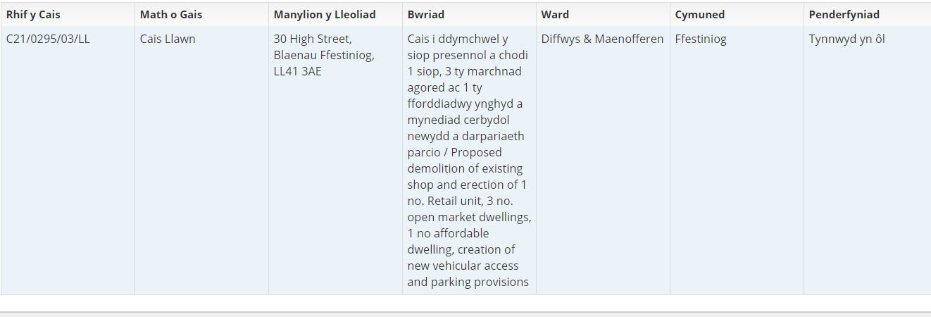

PLANNING AUTHORITY: SNOWDONIA NATIONAL PARK:
Rhif Cais / App No | Lleoliad / Location | Disgrifiad / Description | Dyddiad derbyn / Date received. | Penderfyniad / Decision
NP5/59/789A | 2 Maes y Coed, Llan Ffestiniog. LL41 4PE | Diwygiad ansylweddol i Ganiatâd Cynllunio NP5/59/789 dyddiedig 20/01/2018 i osod ffenestr llawr cyntaf ychwanegol ar y drychiad Gogledd Gorllewinol, drysau patio ar y llawr isaf a dwy ffenestr to ar y drychiad Gogledd Dwyreiniol, newid i’r ffenestri, drychiad y ports ar fyrddau cladin ar edrychiadau De Gorllewinol a Gogledd Gorllewinol  Non-material amendment to Planning Consent NP5/59/789 dated 29/01/2018 for the installation of additional first floor window on North West elevation, ground floor patio doors and two rooflights on North East elevation, changes to fenestration to porch elevation and cladding boards to South West and North West elevations | 12/04/21 | Gwrthodwyd / Refused.
NP5/59/798 | 10 Heol yr Orsaf, Llan Ffestiniog. LL41 4NN | Amnewid estyniad deulawr yn y cefn a garej unllawr ar wahân.  Erection of replacement 2 storey rear extension and single detached garage | 14/04/2021 | Caniatawyd gydag amodau.  Permitted with conditions.

DECISION: To accept the information.

11055/06/21 19. NOTICE OF MOTION
By Councillor Gwenlli Evans:
“I've had a Manod resident talk about their concerns about speeding along the A470 and Cae Clyd. As a council I propose to ask the Welsh Government and Gwynedd Council (to Cae Clyd) to install traffic calming measures to protect residents.”
DECISION: The motion was seconded by Councillor Mark Thomas. In addition to the Welsh Government and Gwynedd Council, it was agreed to write to the police to raise awareness of this issue.
11056/06/21 20. NOTICE OF MOTION
By Councillor Gwenlli Evans:
“I propose to the Council to consider employing an individual as a community carer who can look after the maintenance and repair of council owned areas and tidy up and ensure that the areas are appropriate and not deteriorated. And to consider if this is an option with this year's budget.”
DECISION: The motion was seconded by Councillor Annwen Daniels. Details of the motion to be discussed at the next Amenities Committee. The clerk will need to ascertain possible budget for the work, and look at pricing options either through set hours contract or price per hour.

11057/06/21 21. NOTICE OF MOTION
By Councillor Ronwen Roberts:
“Following reports of cars speeding through Oakeley square, and the possibility of an resulting accident, The residents of Oakeley Square Tanygrisiau are requesting that a 20mph speed limit be imposed to safeguard the residents, and in particular to ensure the safety of the number of children who regularly use the open space for recreation.
The speeds bumps already in place are not a sufficient deterrent on their own, and 20mph signs to all three entrances to the square would send a clear message that extra care needs to be taken.”
DECISION: Councillor Glyn Daniels suggested an amendment to the motion, to contact Gwynedd Council and put speed restriction measures in several areas around Blaenau Ffestiniog, including Fron Fawr, Tai Gelli etc. The amendments was seconded by Councillor Mark Thomas. The Town Council agreed for the amendment to be take forward.

DEVELOPMENTS IN THE AREA
11058/06/21 22. HEALTH
Nothing to discuss.

11059/06/21 23. PUBLIC SPACES PROTECTION ORDER (GDMC) CONSULTATION: DOG CONTROL
DECISION: It was agreed that Councillors completing the questionnaire separately would be more beneficial. Clerk to send this link to the Councillors to complete.
11060/06/21 24. GWYNEDD COUNCIL WORK PROGRAMME JUNE 2021
DECISION: To accept the information.

TOWN COUNCIL
11061/06/21 25. TOWN COUNCIL STAFF REPORT.
• Notice of two empty seats released on Town Council website and Facebook page. Those seats are for Tanygrisiau ward (1) and Bowydd and Rhiw ward (1). The notice ends on the 29th of June, 2021.
• The Deputy Clerk returns to work on a gradual return tomorrow.
• Continued administration of the Center, and work on first draft of online booking system. Grant application to Cist Gwynedd completed for upgrading the Kitchen in the Day Care room - decision to follow.
• Assist the Committee with the Innovation Gwynedd Rural project which will see the Center piloting 3 new services, namely pop-up shops, hot desks and a local market.
• Follow up on the bus Shelter at Manod, near Wynnes. Awaiting a decision from the Welsh Government regarding the crossing.
• Settling the new Councillors with a new email. Laptops servicing ongoing.
• Draft grant application for Local Places for Nature completed, and to be discussed at Amenities Committee before being sent to Keep Wales Tidy.
• Acting Finance Officer, Gwynedd Council officer has completed his work with the Town Council this week.
• Painting of playground equipment to start next week, starting at Cae Gild play park. The intention is to keep the public informed of developments on the Facebook page.
Councilor Annwen Daniels asked the clerk what arrangements were in place to treat the asbestos found near Cae Baltic. The Clerk confirms that a company needs to be organized to collect it. It was noted that this needed to be done urgently.
DECISION: To receive the information.

MATTERS ARISING
11062/06/21 26. Playing Fields
- Urgent removal of asbestos near Baltic Field.
- Original quotation / agreement with North Wales Fencing needed to be checked in relation to the fence on a section of Cae Manod, and the need for the work to be completed and the fence placed on top of the wall.
- Check Gwynedd Council's website which currently marks 'The Square' park under the responsibility of Gwynedd Council.
- Need to re-install the 'Crazy Golf' equipment in The Park.
- Zurich insurance company response to volunteers being able to do some maintenance - it was noted that voluntary work can fall under the public liability insurance policy as long as the individuals are competent at work and a risk assessment has been completed.
DECISION: To receive the information and discuss it further at the next Amenities Committee.

11063/06/21 27. Opportunity for Councillors to report back to Council following their attendance at external committees.
Councilor Annwen Daniels mentioned that she and Councillor Rory Francis had recently met with 'Welsh Slate'. Reports that the slate industry and demand are quite strong recently. Starting to transport slate by rail from Llandudno Junction, no short-term plan in place but positive rumors that there will be major investment in moving slate waste away from North Wales, and replacing it with aggregate, which will in turn creates local jobs. The meetings are beneficial in keeping in touch with larger companies in the area.
Transport for Wales has given Y Dref Werdd funds to create a mural in the bus shelter near the train station.
Councillor Glyn Daniels gave an update on Twrog Community Energy, A business application submitted to the NDA, and the hope is to receive £ 300,000 to open a Fund to promote the communities of the Maentwrog catchment area (to include Bro Ffestiniog).
11030/05/21 28. NEWS FROM GWYNEDD COUNCIL
Nothing to report.

11064/06/21 29. OTHER NEWS

That the St David's flag continues to fly on the Town Council's flag pole. It is suggested that it be removed and replaced with another flag as already approved at a previous Ordinary Meeting at the beginning of 2020. to be discussed further at the next Amenities Committee.

11065/06/21 30. Lleucu Gwenllian – Chwedl Calaffate.

The Town Council received information that Lleucu Gwenllian has given recognition to the Patagonia Scholarship in her latest book, "Chwedl Calaffate", including a note to thank Ffestiniog Town Council for the opportunity.

CORRESPONDANCE

11066 /06/21 31. ‘Clerks and Councils Direct’ volume May 2021
11067/06/21 32. Communication from ‘Wales for Europe’.

DECISION: To accept the correspondance, and to share ‘Wales for Europe” message on the Ffestiniog Town Council Facebook page.

The meeting closed at 9.03pm

CHAIR

THE NEXT ORDINARY MEETING OF THE TOWN COUNCIL IS TO BE HELD ON THURSDAY 8TH JULY 2021
ONLINE VIA ZOOM AT 7:00 p.m.

THE AGENDA FOR THE ORDINARY MEETING 8TH JULY 2021
WILL CLOSE ON 1st JULY 2021

